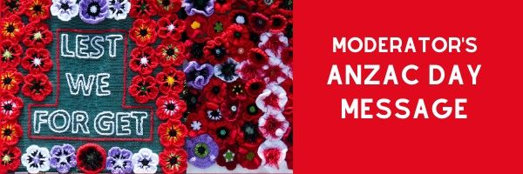

17 April 2020

Greetings

“Love one another as I have loved you. Greater love has no one than this, that he lay down his life for his friends. You are my friends.” (John 15:12-14)

The words of our Lord and Saviour Jesus Christ ring and echo loudly in our situation today.

In fact, as we all attest to this truth in life, it is the sound of Jesus’ words that permeate our being as we move from Easter toward Anzac Day. Easter was very different this year, with the crowds and gatherings, worship and fellowship, meals of fish and bread, communion - all carried out using digital communication. This is an unprecedented situation due to unusual times affecting the whole world. What stands out for me each and every year is: “Jesus died on the Cross, for you and I”.

ANZAC Day appropriately follows Easter on our calendar. The underlying theme of the Cross is echoed by the soldiers that died for “God, King and country”. Their lives, their commitments, their sacrifices were for you and I, which is commemorated on ANZAC. It is poignant, significant and sacred.

Many lives were lost. We are forever indebted to the brave men and women who died on the frontier of the battlefields for our freedom, for all that we have. We will never forget them. We remember and recall ANZAC every year, and we educate our children about this alliance. We will remember them: they are our heroes, our champions, our “game-changers”.

Today, in our world and in our country, we have new heroes, champions and “game-changers”. These new heroes are the many men, women and children who have stepped up, arisen, “taken the bull by the horns” and made a difference in the lives of many during the Covid-19 crisis. To all the essential workers (police, nurses, doctors, firefighters, rest home carers, orderlies, supermarket workers, chaplains... the list is long), thank you. Bless you.

Your service for the masses, for our country, is both courageous and brave. You are valued and loved, appreciated and cherished. You risk your lives every day against an unseen enemy - Covid-19. You work is in the same order of sacrifice as our Lord Jesus on the Cross and the soldiers on the battlefields. Your lives are on the line every time you step up and step out. We salute you and keep you and your loved ones in our prayers. We will not forget you.

Jesus said, “I came that you may have life, life in all its fullness”. (John 10:10)

Blessings
Fakaofo

Yours in Christ's service
Right Reverend Fakaofo Kaio
Moderator of the Presbyterian Church of Aotearoa New Zealand
E Moderator@presbyterian.org.nz

